TAINA Technical Test

Write a simple web application using C# and either MVC or a Single Page Application technology (ReactJS, Angular, KnockoutJS) in Visual Studio 2017 that allows a user to manage a list of ‘Person’ objects. The user should have the ability to edit details of an individual person and to add new people.

The data for a person is stored in this table:

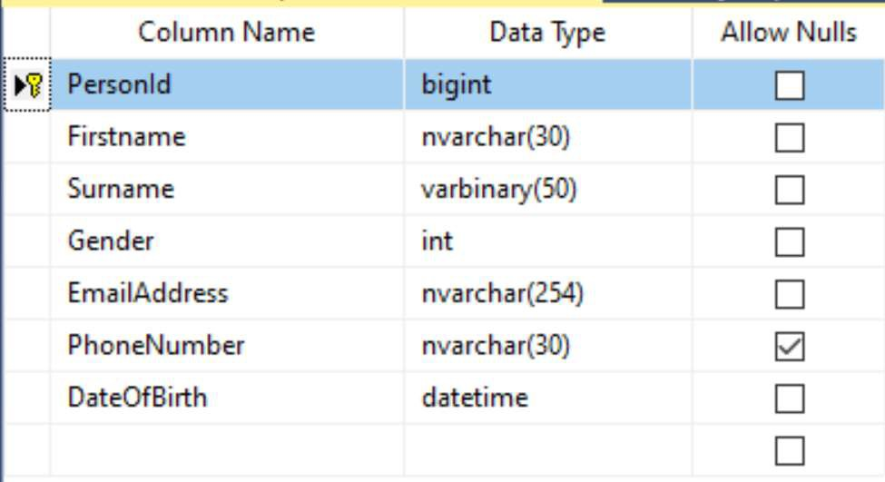

The data is sensitive personal data and so consideration should be given to security.

The system, whilst simple, is anticipated to be a high-performance system handling millions of people in the database and accepting millions of hits per day to the website. As such we are looking at:

* How you structure your solution, i.e. use of n-tier architecture
* The level of error checking in your code – defensive programming!!
* How you cater for standard production issues (e.g. database not available, etc.)
* How you would spot and debug any production issues once in live
* How robust your code is
* Your strategies for handling the high volumes of records and high volumes of hits to the website, e.g. use of caching
* The attention to detail on the user interface Some pointers on the tech test:
* Don’t rush it
* Keep it simple
* Write highly defensive / paranoid code – try/catch everywhere, avoid null pointer exceptions at all costs!
* Log everything
* Write unit tests, ideally with dependency injection. You do not need full test coverage – just demonstrate that you know how to wire up tests.

Sketch out how you would scale your solution up across a server farm. Cloud solutions are acceptable.